**ADJ American DJ Penta Pix 5x15-Watt RGBW LED**

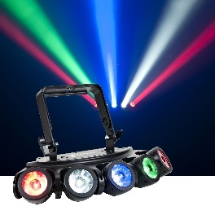

**Specifications**:

|  |  |
| --- | --- |
| * Light source | * 5 x 15W 4-in-1 RGBW quad LEDs |
| * Operational modes | * sound active * auto run * RGBW dimmer mode * color macro mode * DMX control * (63) preset color macros |
| * DMX channel modes | * 4, 6, or 22-channels * 3-pin DMX in/out connections * Strobe speed (controlled via DMX) * 0-100% electronic dimming (Controlled via DMX) |
| * Power consumption | 77W maximum |
| * AC connection | * PowerCON in/out * daisy chain power |
| * Multi-voltage operation | * AC 100-240V 50/60Hz * Dimensions 21” x 11” x 10.25” / 530 mm x 280 mm x 260mm (LxWxH) |
| * Weight | 12 lbs. / 5.4 kg. |
| **Features** | * New ACL (Advanced Collimator optic Lens) for razor sharp 6° beams * 5-zone pixel control * 15 exciting built-in light shows with sound active control * Runs extremely cool! - no duty cycles! – run all night! * (5) selectable dimmer curves * Includes scissor yoke + safety hook on rear panel * 4-button DMX LED display |

**American DJ ON-X LED Sweeper**

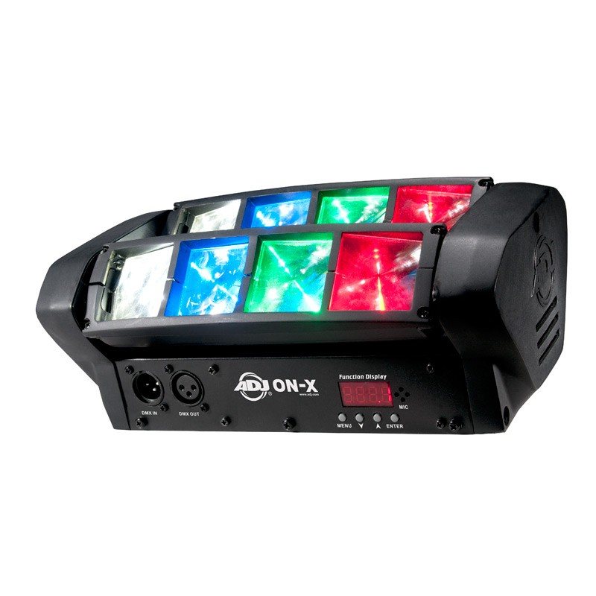

**Specifications:**

|  |  |
| --- | --- |
| LED Source | 8 x 3 W R/G/B/W LEDs (2 x red, 2 x green, 2 x blue, 2 x white) |
| LED Life Expectancy | Approximately 50,000 hours |
| Photometrics | 5570 lux at 6.5' / 2 m 1200 lux at 13.1' / 4 m |
| Beam Angle | 4° |
| Tilt | 270° 2 x stepper motors |
| Dimming | Electronic: 0-100% Curves: Standard, Stage, TV, Architectural, Theater |
| Operation Modes | Show, Sound-Active, DMX Controlled |
| Built-In Programs | LED pulse, strobe effect |
| DMX Channel Modes | 2, 9, 11, 12, 16, 18 |
| DMX 512 Protocol | Input: 3-pin XLR  Output: 3-pin XLR |
| Display/Controls | 4-button DMX LED display |
| Wireless Control | ADJ UC IR remote (available separately) |
| Input Voltage | 100-240 VAC, 50/60 Hz, auto-sensing |
| Power Connectors | Input: IEC Output: IEC |
| Power Linking | 120 V: Maximum 15 fixtures  230 V: Maximum 28 fixtures |
| Power Consumption (Maximum) | 46 W |
| Fuse | 2 A |
| Mounting | Bracket |
| Dimensions (LxWxH) | Without Bracket: 11.25 x 6 x 4.25" / 283 x 151 x 110 mm With Bracket: 11.25 x 6 x 5.75" / 283 x 151 x 147 mm |
| Weight | 5.5 lb / 2.5 kg |

**American DJ XS 600 Moving Head Fixture**

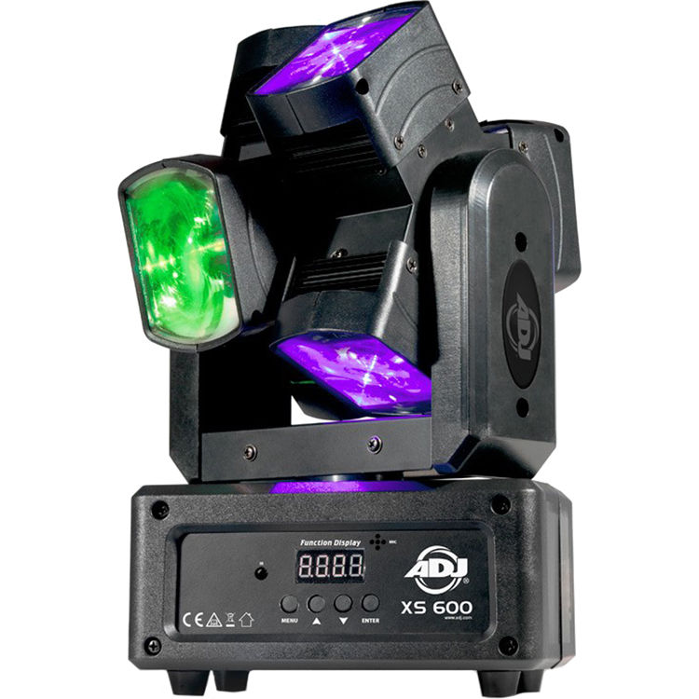

**Specifications:**

|  |  |
| --- | --- |
| LEDs | 6 x 10 W (4-in-1) RGBW LEDs (red, green, blue, white) |
| LED Life Expectancy | 50,000 hour rating |
| Color Mixing | RGBW |
| Photometrics | 6.65' (2 m): 5331 lux 13.12' (4 m): 1242 lux |
| Beam Angle | 5° |
| Operational Modes | 3 x Modes: DMX, show mode, and sound active |
| Built-in Shows | 9 x shows |
| Duty Cycle | None |
| DMX Channel Modes | 2 x Modes: 25 and 31 channels |
| DMX Connectors | 1 x XLR 3-pin input 1 x XLR 3-pin output |
| Display/Controls | 4-button menu system with LED display |
| Wireless Control | UC IR Remote (available separately) Airstream IR App (free download, requires additional hardware) |
| Power Input Requirement | 100 to 240 VAC, 50 / 60 Hz |
| Power Connectors | 1 x IEC input 1 x IEC output |
| Power Linking | Up to 8 fixtures |
| Power Consumption | 60 W |
| Power Cable Length | 4 ft (1.2 m) |
| Fuse | 1 A |
| Working Position | Any safe, secure position |
| Dimensions (L x W x H) | 7.75 x 5.0 x 12.5" (19.6 x 12.6 x 31.8 cm) |
| Weight | 7.0 lb (3.0 kg) |

**american-dj-inno-pocket-spot-twins-dual-moving-heads**

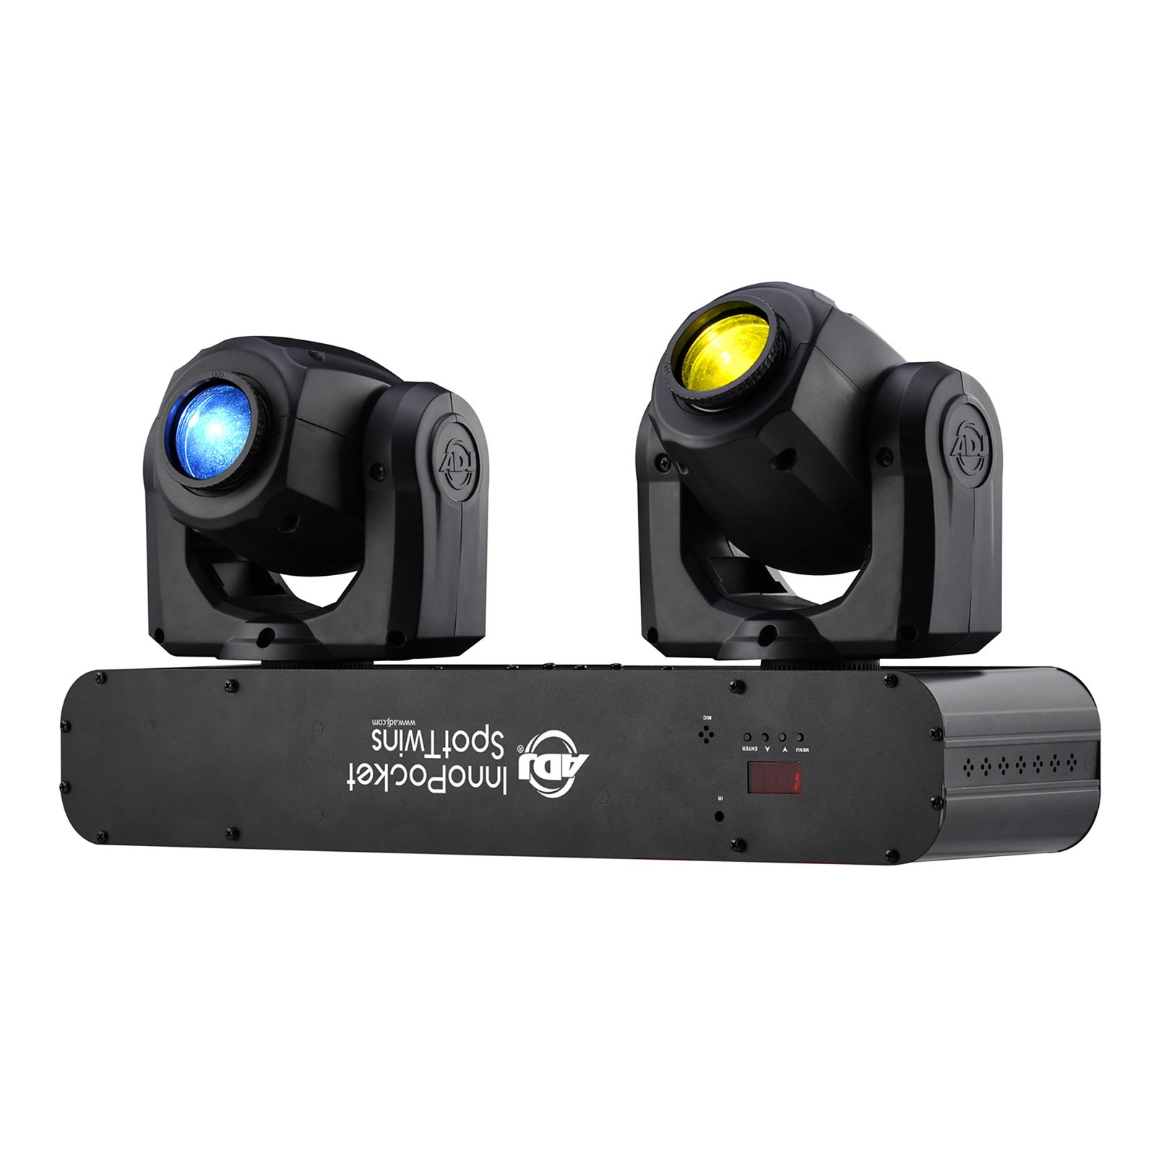

**Specifications:**

|  |
| --- |
| High output dual mini Moving Heads, each with a bright white 12W LED source |
| 7 Colors + white |
| 7 fixed gobos + spot |
| Separate color & gobo wheels |
| Manual focus |
| 3 Operational modes: DMX Control, Sound Active Mode & Show Mode |
| 2 DMX channel modes: 19 & 23 Channel modes |
| 4 Built-in shows |
| Gobo Shake effect |
| Gobo scroll mode |
| Beam Angle: 13-degrees |
| 540° pan / 230° tilt (16-bit) |
| Pan /Tilt Inversion mode |
| 5 selectable Dim Curves (Standard, Stage, TV, Architectural & Theatre) |
| Shutter: Pulse effect; random strobe slow to fast |
| Dimming: 0% - 100% |
| Fan Cooled |
| Hole for pole mounting |
| 2 Omega bracket included to hang from truss |
| Linkable: DMX via 3-pin XLR cable |
| Optional IR wireless remote control: Full On, Stand by, Strobe, Color Change, Dimming, Sound Active On/Off  (ADJ UC IR Not Included) |
| Compatible with the ADJ Airstream IR App |
| PWM (Pulse Width Modulation: 4K |
| Strobe Rate: 0.3-19HZ |
| DB Rating @ 1Meter: Front: 45; Back: 43; Left: 42; Right: 43; Top: 45 |
| Power consumption: 85W |
| Power Cable Length: 1.5M (IEC) |
| Light output: 4823 LUX @ 2M; 1240 LUX @ 4M (13-degree beam) |
| Multi-voltage Operation: AC 100 - 240V, 50/60Hz |
| LED Source: 12W White LED source (Rated at approximately 50,000 hrs) |
| Dimensions (LxWxH): 19.25” x  6” x 13” / 487 x 153 x 327mm |
| Weight: 17 lbs. / 7.6 kgs. |
| ETL Approved |

# **Blizzard Lighting Stimul-Eye Multi-Beam Effect Moving Head Fixture with 7x 10W White LED**

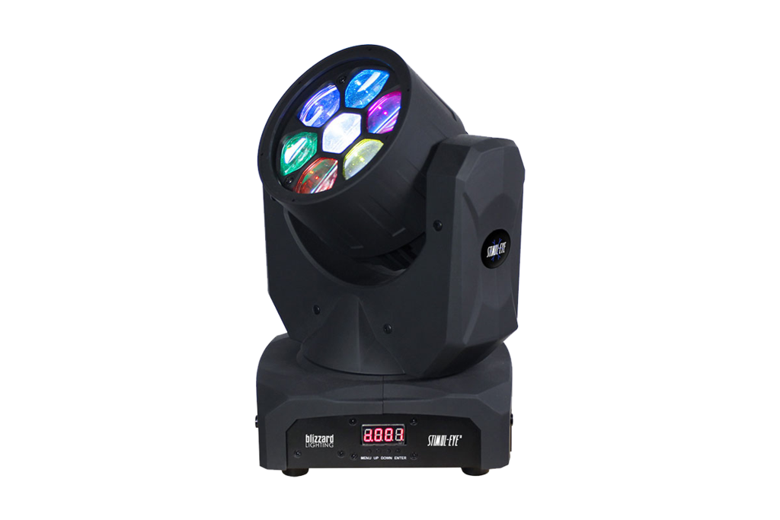

**Specifications:**

|  |  |
| --- | --- |
| **Control** | Protocol: USITT DMX-512 DMX Channels: 19/12-channels Input: 3-pin XLR Male Output: 3-pin XLR Female Other Operating Modes: Standalone, Master/Slave, Sound Active Mode |
| **Light Source** | 7x 10w White CREE LEDs |
| **Beam Angle** | 5 - 40 deg. |
| **Luminous Intensity** | 36890lux at 1m 16000lux at 2m 10014lux at 3m 4610lux at 4m 2808lux at 5m |
| **Movement Range** | Pan: 540 deg.  Tilt: 250 deg. |
| **Power** | Operating Voltage: 90-240VAC 50/60Hz  Power Consumption: 52W, 0.7A, PF: 0.59  Fuse: 5A |
| **Max. Operating Temperature** | 40 deg. C / 104 deg. F (ambient) |
| **Dimensions (W x D x H)** | 8.75 x 6.6 x 12.4" / 22.23 x 16.76 x 31.50cm |
| **Weight** | 9.3lbs / 4.22kg |

**Chauvet Rogue R1 FX-B Moving Head System**

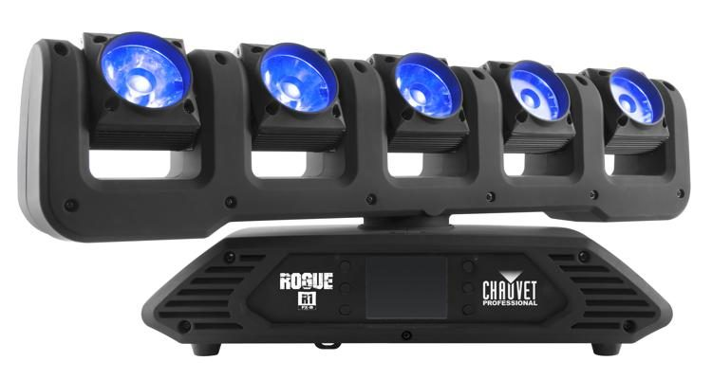

**Specifications:**

|  |  |
| --- | --- |
| Light Source | 5 x RGBW LEDs, 15 W (4 A) |
| Life Expectancy | 50,000 hours |
| Illuminance | 5361 lux @ 16.4' / 5 m |
| Beam Angle | 7° |
| Field Angle | 11° |
| Pan Range | Infinite / 540° / 360 ° / 180° |
| Tilt Range | Infinite / 540° / 270° / 180° |
| Dimmer | Electronic |
| Dimmer Curves | 4 |
| Shutter/Strobe | Electronic |
| Strobe Rate | 0 - 20 Hz |
| Color Mixing | RGBW, RGBW (16-bit) |
| Color Temperature | 2800 to 6500K |
| Protocols | DMX, Art-Net, sACN, Kling-Net* *No pan/tilt support in Kling-Net |
| DMX Connectors | Input: XLR 3-pin, XLR 5-pin, etherCON Output: XLR 3-pin, XLR 5-pin, etherCON |
| DMX Channel Modes | 9, 15, 17, 18, 20, 23, 25, or 47 channels |
| Input Voltage | 100 to 240 VAC, 50/60 Hz (auto-ranging) |
| Power Connectors | Input: powerCON  Output: powerCON |
| Power Linking | 120 V: 9 units  208 V: 15 units  230 V: 18 units |
| Power Cable | Edison to powerCON |
| Power Cable Length | 5' / 1.5 m |
| Power Consumption | 207 W, 1.68 A @ 120 V, 60 Hz 200 W, 0.938 A @ 208 V, 60 Hz 197 W, 0.876 A @ 230 V, 50 Hz |
| Housing Material | High-impact flame-retardant polymer |
| IP Rating | IP20 |
| Working Position | Vertical or inverted |
| Cooling | Fan-cooled |
| Certifications & Approvals | CE, MET |
| Dimensions | 25.19 x 7.05 x 9.72" (640 x 179 x 247 mm) |
| Weight | 24 lb (11 kg) |

**chauvet-dj-beamer-6-fx-3-in-1-led-rgb-w-beam-laser-strobe-effect**

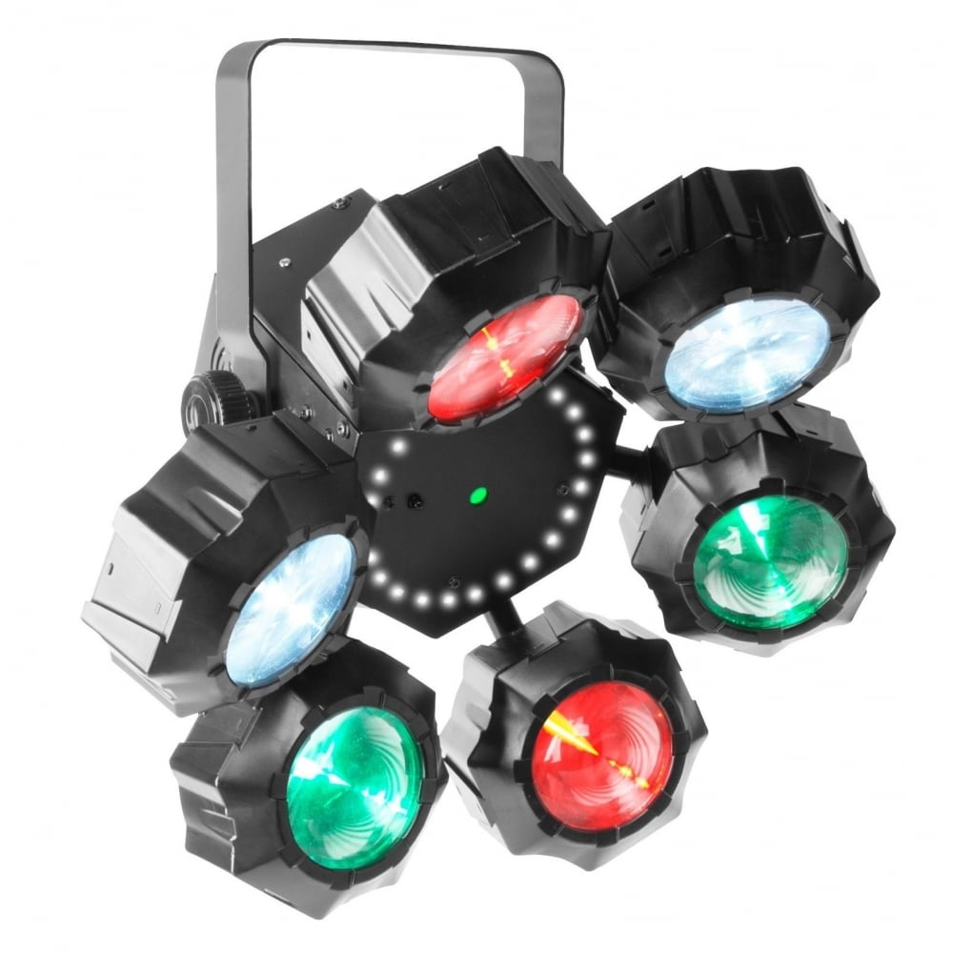

**Specifications:**

|  |
| --- |
| * **DMX Channels:** 2 or 15 * **DMX Connectors:** 3-pin XLR * **Light Source:** (Beam): 6 LEDs (RGBW) 5 W, (2 A), 50,000 hours life expectancy (Strobe): 24 LEDs (White) 0.3 W, (0.1 A), 50,000 hours life expectancy (Lasers): 650 nm/100 mW (Red) laser diode, 532 nm/30 mW (Green) laser diode * **Strobe Rate:** (Beam): 1 to 20 Hz (Strobe): 1 to 20 Hz * **Beam Angle:** 3° * **Power Linking:** 12 units @ 120 V; 22 units @ 230 V * **Input Voltage:** 100 to 240 VAC, 50/60 Hz (auto-ranging) * **Power and Current:** 41 W, 0.6 A @ 120 V, 60 Hz 40 W, 0.3 A @ 230 V, 50 Hz * **Weight:** 6.2 lb (2.9 kg) * **Size:** 15.3 x 15.3 x 11.2 in (390 x 390 x 285 mm) * **Approvals:** CE, FDA * **Optional Controllers:** IRC-6 |

**CHAUVET DJ Helicopter Q6 - Rotating Multi-Effects Light with Laser (RGBW)**

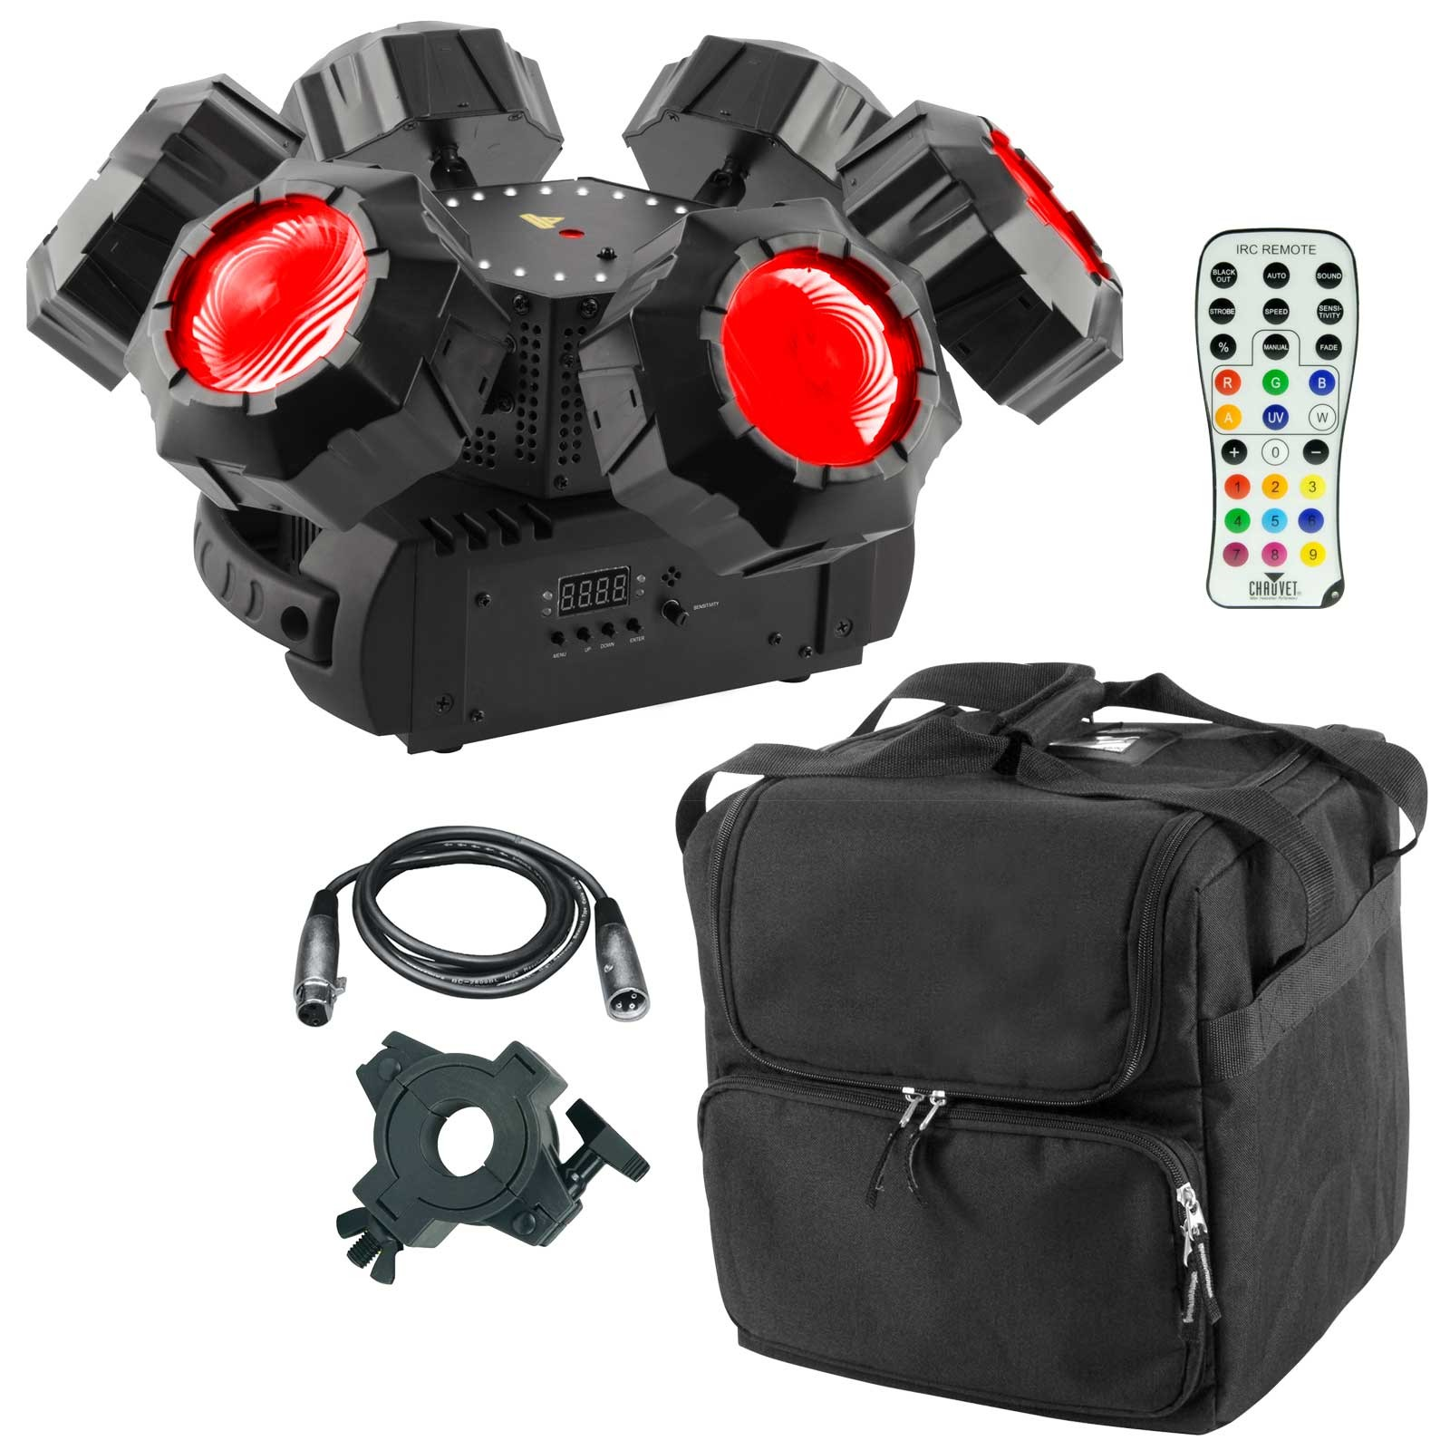

**Specifications:**

|  |  |
| --- | --- |
| DMX | DMX Channels: 3 or 16 DMX Connectors: 3-pin XLR |
| Pan & Tilt Range | 360° |
| Light Source | Beam: 6 (RGBW) 6.9 W, (2 A), 50,000 hours life expectancy Strobe: 24 LEDs (white) 1 W, (281 mA), 50,000 hours life expectancy Laser: 650 nm / 100 mW (red) laser diode, 532 nm / 30 mW (green) laser diode |
| Strobe Rate | Beam/Strobe: 0 to 20 Hz |
| Beam Angle | 3° |
| Power Linking | 12 Units at 120 V 23 Units at 230 V |
| Input Voltage | 100 to 240 VAC, 50/60 Hz (auto-ranging) |
| Power | 41 W, 0.7 A at 120 V, 60 Hz 44 W, 0.4 A at 230 V, 50 Hz |
| Approvals | CE, FDA |
| Dimensions | 23.8 x 7.2 x 10.5" / 604.5 x 182.9 x 266.7 mm |
| Weight | 8.8 lb / 4.0 kg |

**Follow-Spot-Stage-Light-FS-2500A-**

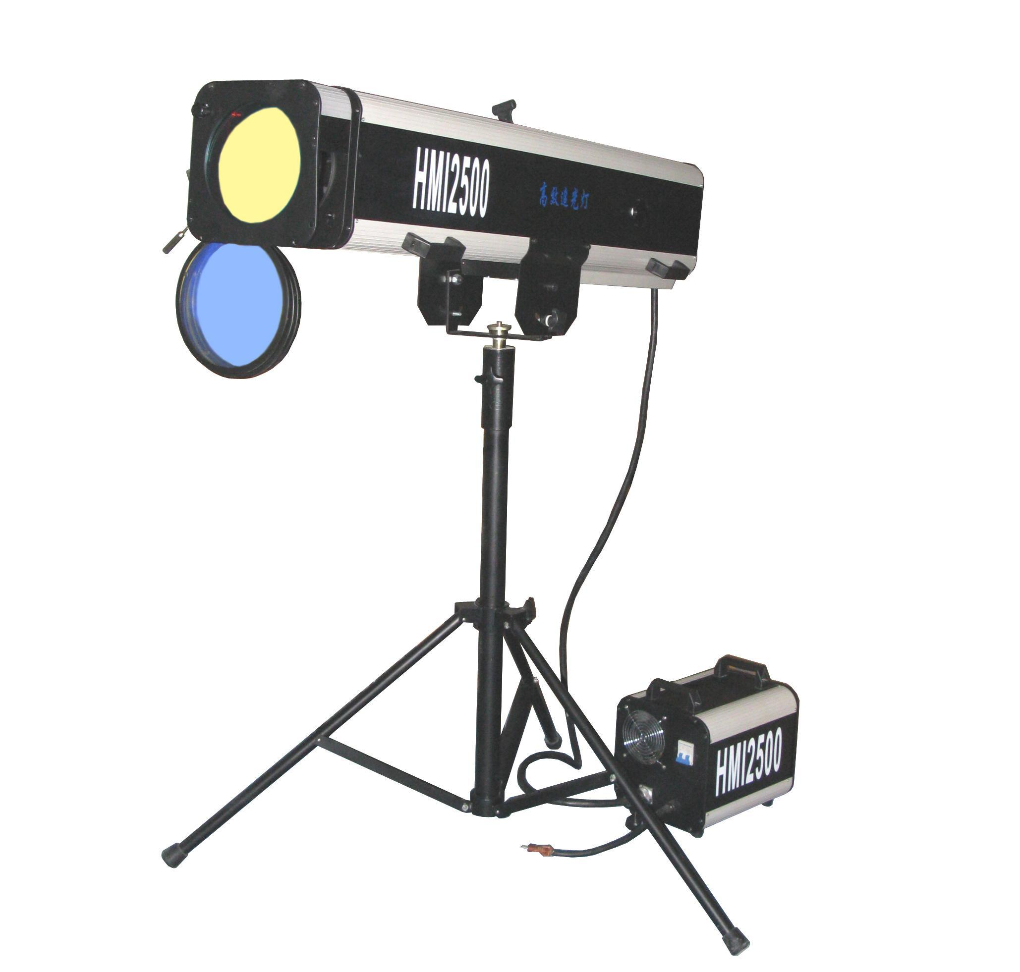

**Specifications:**

|  |  |
| --- | --- |
| Voltage | AC110V/220-240V, 50/60Hz |
| Fuse | 20A |
| Power consumption | 2800W |
| Lamp | HMI 2500W |
| Color Wheel | 4 colors + open |
| Beam Angle | 15° |
| Beam Distance | 200Meters |
| Functions | Strobe(1-10times/s), Iris etc |

**Inno Spot PRO-**

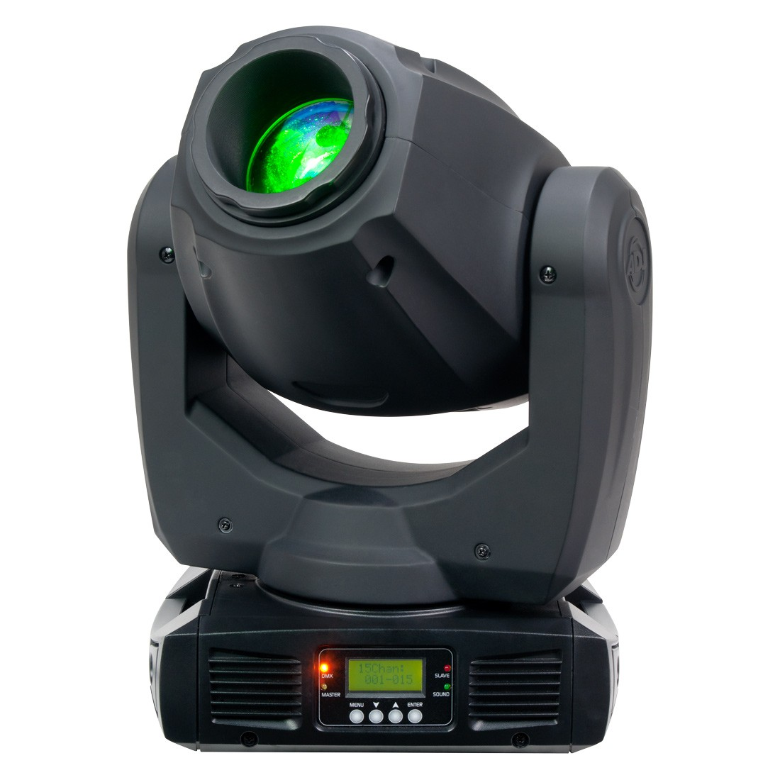

**Specifications:**

|  |  |
| --- | --- |
| Light Source | 80W LED |
| Bulb Life | Approximately 50,000 hours |
| Colors | 8x + white |
| Gobos | 6x rotating + spot |
| Gobo Size | 24 mm (20 mm viewable / 0.2 mm thickness for 4 metal gobo, 1.1 mm thickness for 2 glass gobo) |
| Zoom | 12 to 17° |
| DMX Channels | 14 |
| Operation Modes | DMX-512, sound active, show mode (4 built-in) |
| Pan & Tilt | 540° / 270° tilt (16-bit) |
| Dimming | 0 to 100% |
| Daisy Chain Capability | DMX Linkable via 3-Pin XLR Cable  Power cable up to 4 units at 120 VAC  Power cable up to 8 units at 220 VAC |
| Compatibility | ADJ UC3 series easy-to-use controllers (sold separately) |
| Power Consumption | 140 W at 110 VAC 134 W at 220 VAC |
| Power Requirements | 100 to 240 VAC at 50/60 Hz |
| Dimensions (L x W x H) | 11.5 x 6.75 x 16.75" (288 x 167 x 425 mm) |
| Weight | 19 lb (8.5 kg) |

**Martin MAC Aura XB LED Moving Wash Light with Flight Case**

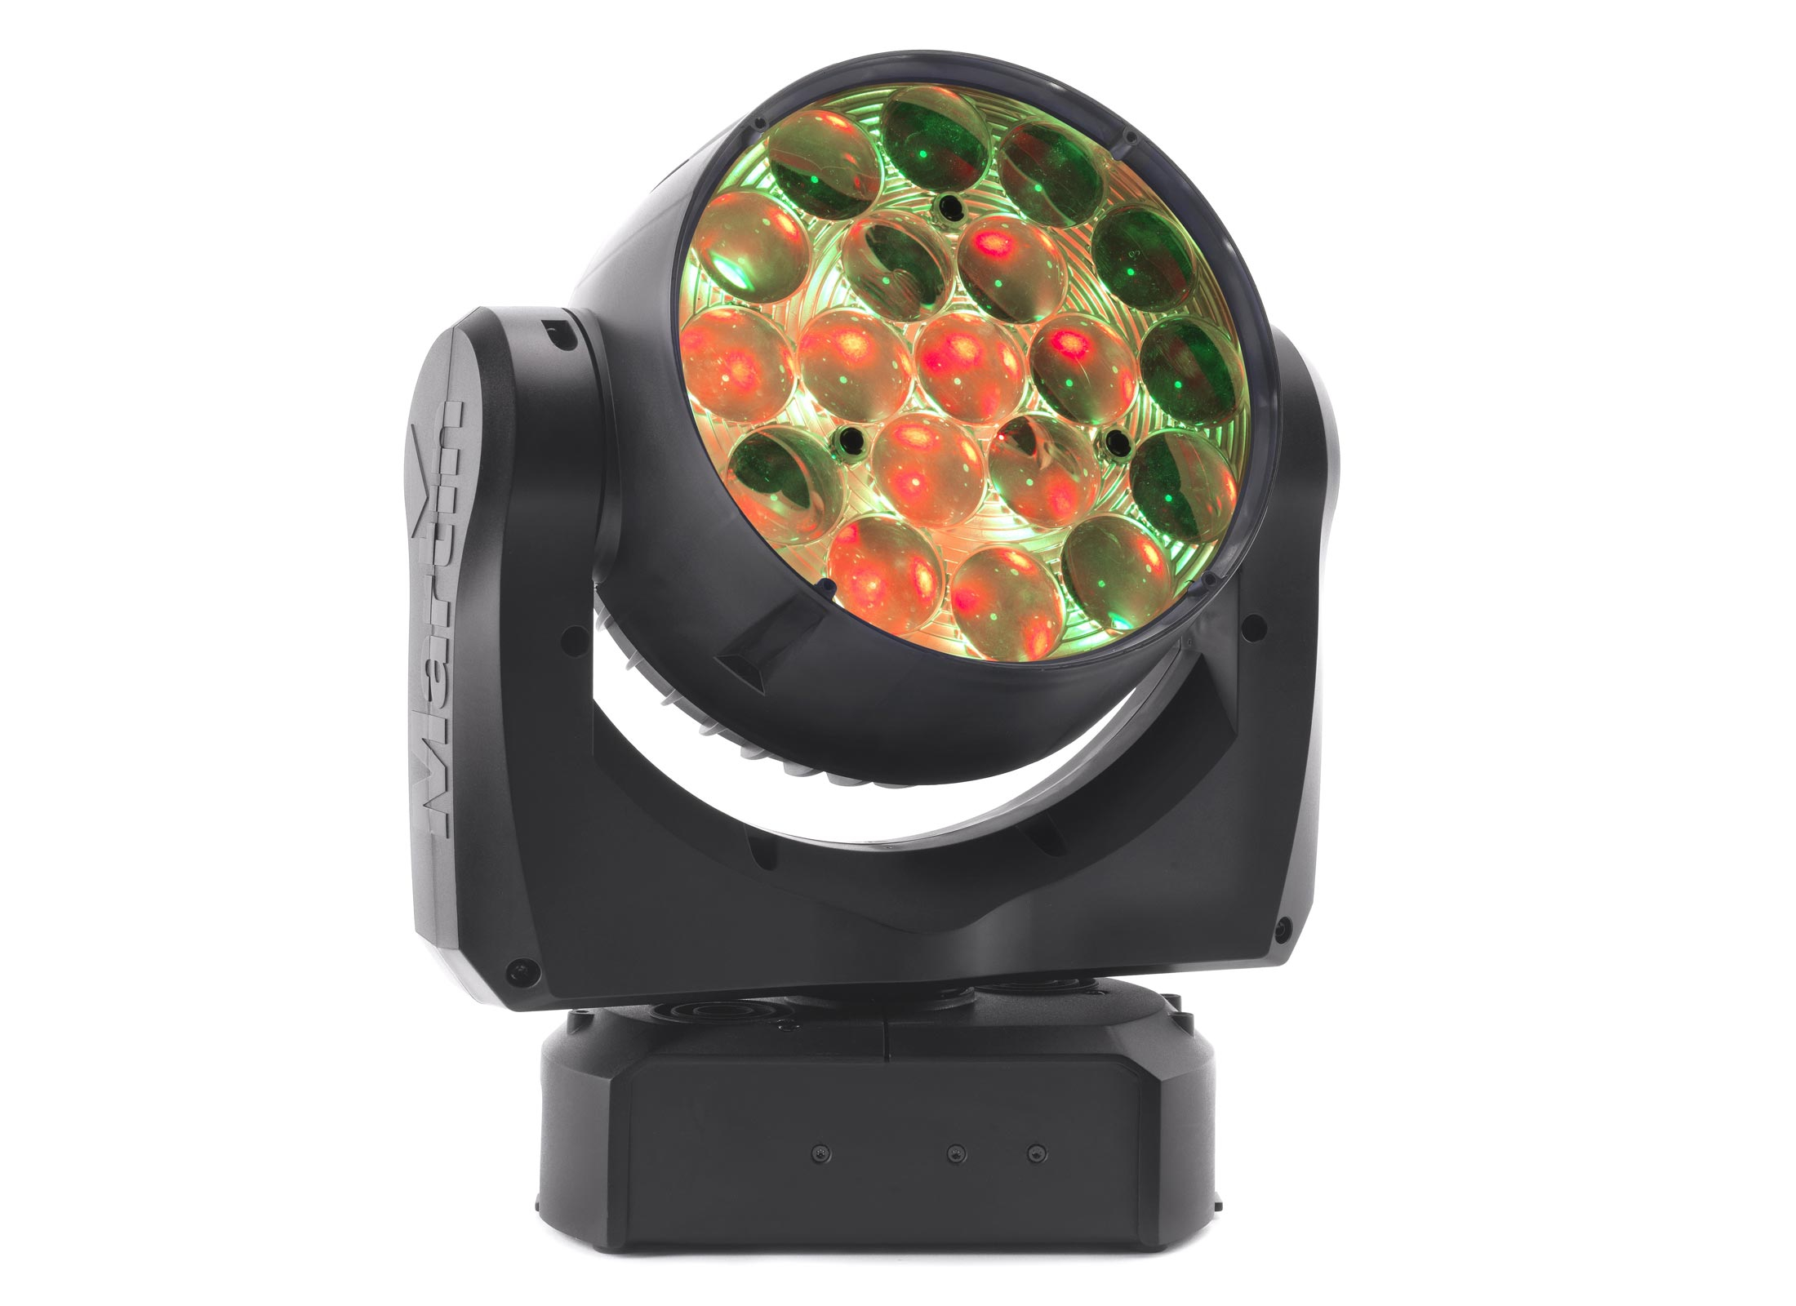

**Specifications:**

|  |
| --- |
| * **LENGTH (ACROSS YOKE)**: 302 mm (11.9 in.) * **WIDTH (ACROSS YOKE)**: 302 mm (11.9 in.) * **HEIGHT (HEAD STRAIGHT UP)**: 360 mm (14.2 in.) * **WEIGHT (WITHOUT ACCESSORIES)**: 6.5 kg (14.4 lbs.) * **BEAM COLOR MIXING**: RGBW * **AURA (SECONDARY LENS ARRAY ILLUMINATION) COLOR MIXING**: RGB * **BEAM COLOR TEMPERATURE CONTROL**: CTO, variable 10 000 - 2500 K * **BEAM AND AURA ELECTRONIC 'COLOR WHEEL' EFFECT**: 33 LEE-referenced colors plus white, variable-speed color-wheel rotation effect and random color * **BEAM AND AURA INDEPENDENT SHUTTER EFFECTS**: Electronic, with regular and random pulse, burst and strobe effects * **PRE-PROGRAMMED EFFECTS**: Range of independent and synchronized Beam and Aura FX, two combinable * **ELECTRONIC DIMMING**: Independent beam and aura, four dimming curve options * **ZOOM**: 10° - 60° (one-tenth peak angle) * **PAN**: 540° * **TILT**: 232° * **PAN AND TILT SPEED**: Adjustable via onboard control panel and DMX * **CONTROL OPTIONS**: Independent or synchronized Beam and Aura control * **CONTROL SYSTEM**: DMX, RDM * **CONTROL RESOLUTION**: 8-bit, with 16-bit control of pan & tilt * **DMX CHANNELS**: 14/25 * **SETTING AND ADDRESSING**: Control panel with backlit graphic display * **DMX COMPLIANCE**: USITT DMX512-A * **RDM COMPLIANCE**: ANSI/ESTA E1.20 * **TRANSCEIVER**: RS-485 * **FIRMWARE UPDATE**: Via DMX with Martin USB Duo DMX Interface Box * **LIGHT SOURCE**: 19x 15W RGBW LED Array System * **LED REFRESH RATE**: Beam 1200 Hz, Aura 4395 Hz * **MINIMUM LED LIFETIME**: 50 000 hours (to >70% luminous output)* * **TOTAL LUMINOUS OUTPUT (WIDE, ONE-TENTH PEAK)**: 6000 lumens * **TOTAL LUMINOUS OUTPUT (NARROW, ONE-TENTH PEAK)**: 4300 lumens * **VIDEO COMPATIBILITY**: Designed for use with HD/high-speed video cameras * *Figure obtained under manufacturer�s test conditions * **MOUNTING POINTS**: M12 hole for rigging clamp, attachment points for surface-mounting bracket * **ORIENTATION**: Any * **MINIMUM DISTANCE TO COMBUSTIBLE MATERIALS**: 200 mm (8 in.) from fixture * **MINIMUM DISTANCE TO ILLUMINATED SURFACES**: 1 m (3 ft. 4 in.) from fixture * **LOCATION**: Indoor use only, must be fastened to surface or structure * **AC POWER**: Neutrik PowerCON TRUE1 NAC3PX dual socket * **AC POWER INPUT SOCKET**: Accepts Neutrik PowerCON TRUE1 NAC3FX-W cable connector * **AC POWER THRU SOCKET**: Accepts Neutrik PowerCON TRUE1 NAC3MX-W cable connector * **DMX DATA IN/OUT**: 5-pin locking XLR * **MAXIMUM POWER CONSUMPTION**: 400 W * **POWER SUPPLY UNIT**: Auto-ranging electronic switch mode * **AC POWER**: 100-240 V nominal, 50/60 Hz * **TYPICAL HALF-CYCLE RMS INRUSH CURRENT**: 10.7 A * **POWER CONSUMPTION, ALL EFFECTS STATIC, ZERO LIGHT OUTPUT**: <25 W * **TYPICAL POWER AND CURRENT** * **100 V, 60 HZ**: 359 W, 3.8 A, PF 0.99 * **120 V, 60 HZ**: 355 W, 3.2 A, PF 0.99 * **208 V, 60 HZ**: 350 W, 1.8 A, PF 0.97 * **230 V, 50 HZ**: 349 W, 1.7 A, PF 0.95 * **240 V, 50 HZ**: 349 W, 1.6 A, PF 0.95 * Measurements made at nominal voltage with all LEDs at full intensity. Allow for a deviation of +/- 10%. * **THERMAL** * **COOLING**: Forced air (temperature-regulated, low noise, user-definable levels) * **MAXIMUM AMBIENT TEMPERATURE (TA MAX.)**: 40° C (104° F) * **MINIMUM AMBIENT TEMPERATURE (TA MIN.)**: 5° C (41° F) * **TOTAL HEAT DISSIPATION (CALCULATED, +/- 10%)**: 1230 BTU/hr. |

**Martin MAC Quantum Profile LED Moving Spotlight with Flight Case**

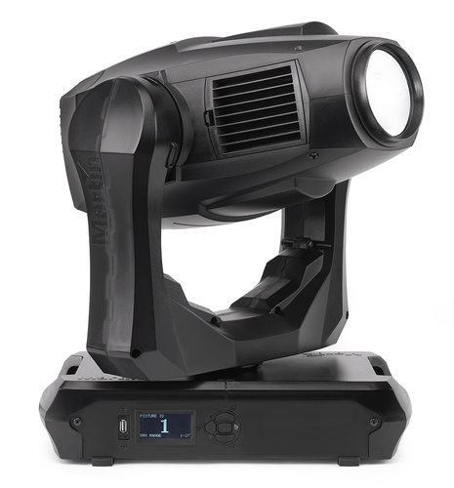

**Specifications:**

|  |
| --- |
| * **LENGTH**: 452 mm (17.8 in.) * **WIDTH (ACROSS YOKE)**: 431 mm (17.0 in.) * **HEIGHT (HEAD STRAIGHT UP)**: 642 mm (25.3 in.) * **HEIGHT (MAXIMUM)**: 648 mm (25.5 in.) * **WEIGHT**: 23.2 kg (51.1 lbs.) * **COLOR MIXING**: CMY, independently variable 0 - 100% * **COLOR WHEEL**: 6 color filters plus open * **ROTATING GOBO WHEEL**: 6 interchangeable gobos plus open, wheel rotation, gobo rotation, indexing and shake * **STATIC GOBO WHEEL**: 10 gobos plus open, wheel indexing, rotation and shake * **BEAM EFFECTS**: Rotating three-facet prism * **ZOOM**: Motorized * **FOCUS**: Motorized, with zoom-focus tracking * **IRIS**: 0 - 100%, pulse effects * **SHUTTER EFFECT**: Electronic, with variable speed regular and random strobe * **ELECTRONIC DIMMING**: Four dimming curve options * **PAN**: 540° * **TILT**: 268° * **PAN AND TILT SPEED**: Adjustable via onboard control panel and DMX * **CONTROL SYSTEM**: DMX * **RDM**: Implemented * **CONTROL RESOLUTION**: 8-bit, with 16-bit control of dimming, gobo indexing, zoom, focus, pan and tilt * **DMX CHANNELS**: 19/27 * **SETTING AND ADDRESSING**: Control panel with backlit graphic display * **DMX COMPLIANCE**: USITT DMX512-A * **RDM COMPLIANCE**: ANSI/ESTA E1.20 * **TRANSCEIVER**: RS-485 * **FIXTURE SOFTWARE UPDATE**: Direct using USB memory stick or via DMX link using Martin USB Duo DMX Interface Box * **LIGHT SOURCE**: 475 W LED engine * **LED REFRESH RATE**: 3000 Hz * **MINIMUM LED LIFETIME**: 50 000 hours (to >70% luminous output)* * **ZOOM RANGE**: 12° - 36° (1:3) * **OUTPUT**: 12 700 lumens * *Figure obtained under manufacturer's test conditions * **MOUNTING POINTS**: 4 pairs of quarter-turn locks * **LOCATION**: Indoor use only, must be fastened to surface or structure * **ORIENTATION**: Any * **MINIMUM DISTANCE TO COMBUSTIBLE MATERIALS**: 0.2 m * **MINIMUM DISTANCE TO ILLUMINATED SURFACES**: 2.0 m * **AC POWER INPUT**: Neutrik PowerCon * **DMX AND RDM DATA IN/OUT**: 5-pin locking XLR * **AC POWER**: 120-240 V nominal, 50/60 Hz * **POWER SUPPLY UNIT**: Auto-ranging electronic switch mode * **MAXIMUM TOTAL POWER CONSUMPTION**: 750 W * **TYPICAL HALF-CYCLE RMS INRUSH CURRENT**: 10.3 A * **TYPICAL POWER CONSUMPTION, ALL EFFECTS STATIC, ZERO LIGHT OUTPUT**: Approx. 50 W * **MAXIMUM TOTAL POWER CONSUMPTION**: 750 W * **TYPICAL HALF-CYCLE RMS INRUSH CURRENT**: 10.3 A * **TYPICAL POWER AND CURRENT** * **120 V, 60 HZ**: 4.8 A, 576 W, PF 0.999 * **208 V, 60 HZ**: 2.8 A, 568 W, PF 0.991 * **230 V, 50 HZ**: 2.5 A, 565 W, PF 0.988 * **240 V, 50 HZ**: 2.4 A, 565 W, PF 0.988 * Measurements made at nominal voltage with all LEDs at full intensity. Allow for a deviation of +/- 10%. * **COOLING**: Forced air (temperature-regulated, low noise, user-definable levels) * **MAXIMUM AMBIENT TEMPERATURE (TA MAX.)**: 40° C * **MINIMUM AMBIENT TEMPERATURE (TA MIN.)**: 5° C * **TOTAL HEAT DISSIPATION (CALCULATED, +/- 10%)**: 2000 BTU/hr. |

# **Sound Active Mini Red-Green Moving Party Stage Laser Light Projector with tripod laser DJ party disco light**

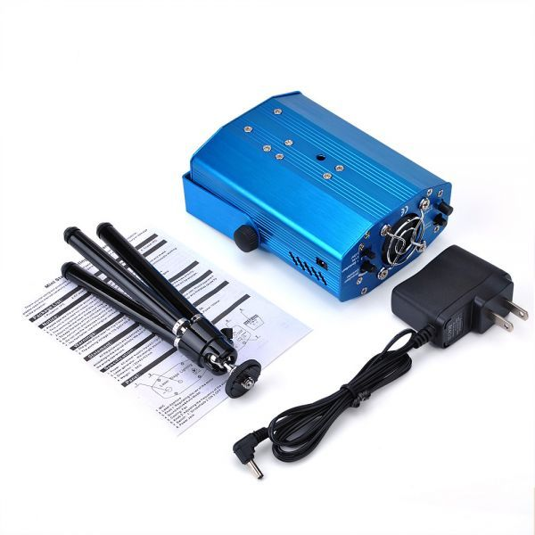

**Specifications:**

|  |
| --- |
| Dynamic star sky  Color: Red, Green  Fully adjustable motion speed  Wavelength/power: 532nm / 50mw (Green), 650nm / 100mw(Red)  Class: III A  Music Active mode (Voice Control) & Auto-mode  Primary Function: Mini Effects Projector with Sound Activation and Stroboflash  Power: AC power supply input 110V-240V / 50-60Hz, output 5.0V / 1.0A  Cooling system: Fan forced cooling system power  Music & Auto Button: Music Active ( Voice control ) & Auto Model  Strobe flash Button: Turn the strobe flash on or off On / Off Button: Turn the power on / off  The body's material: Aluminum Alloy  Certification: CE, FCC, RoHS  Dimension: about 130x92x52 mm |

**American DJ Starburst 6-Color LED Sphere Effect - DMX (RGBWA+UV)**

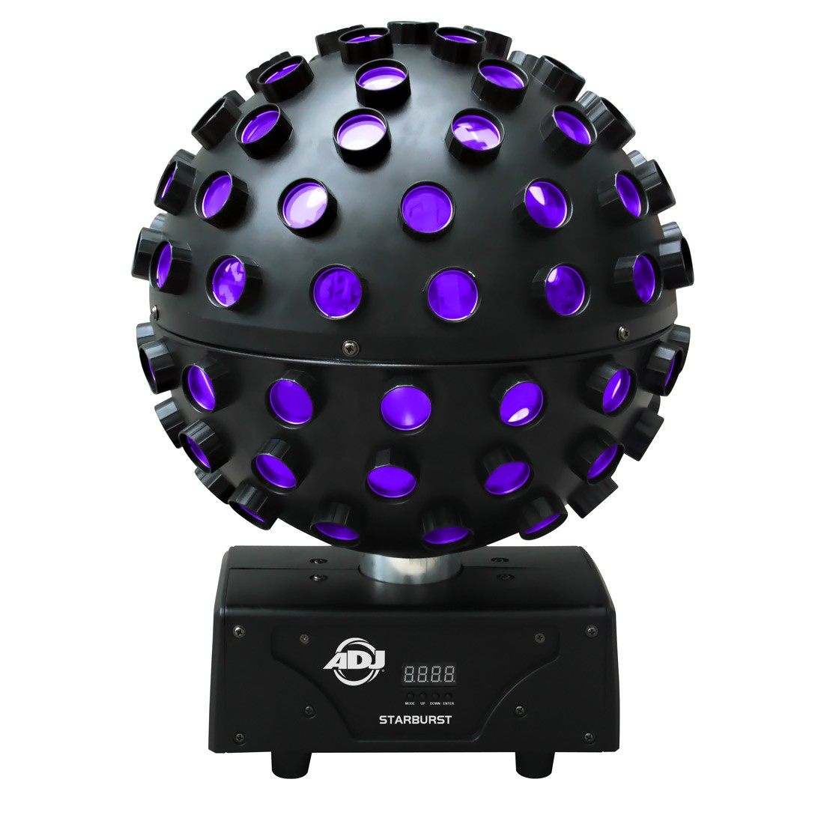

**Specifications:**

|  |  |
| --- | --- |
| Light Source | 5x 15W HEX RGBWA+UV (6-in-1) LEDs (red, green, blue, white, amber, and UV) Lamp Life: 50,000 hours |
| Beam Angle | Beam Angle: 1° |
| Voltage | 100 to 240 VAC, 50/60 Hz (IEC input only) |
| Power Consumption | 55 W |
| Dimensions (L x W x H) | 12.5 x 12.5 x 16.3" / 31.8 x 31.8 x 41.3 cm |
| Weight | 8.0 lb / 3.6 kg |